# Assignment 4: Logistic Regression

## 1 Classification with Linear Regression

### 1. Provide the coefficients β of the linear regression (on x and y) and explain shortly how you computed them.

Linear regression function: $$\hat{f}\left(x\right)=b_{1}x+b_{0}$$

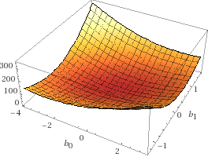Minimize: $$EPE\left(\hat{f}\right)=E{\left(Y-\hat{f}\left(X\right)\right)}^{2}={\left(0+2b_{1}+b_{0}\right)}^{2}+{\left(0+b_{1}+b_{0}\right)}^{2}+{\left(1-0.5b_{1}+b_{0}\right)}^{2}+{\left(0-0.6b_{1}+b_{0}\right)}^{2}+{\left(1-5b_{1}+b_{0}\right)}^{2}+{\left(1-7b_{1}+b_{0}\right)}^{2}$$

Wolfram Alpha gives following solutions:

$$\left(b_{0}, b_{1}\right)= \left(-\frac{11258}{37565},\frac{894}{7513}\right)$$

### 2. Classify each of the 6 samples with your linear regression model. Explain how you map the continuous output of the linear model to a class label

$$\hat{f}\left(x\right)= \left\{0.718381, 0.418688, -0.0308532, -0.0608226, -1.37948, -1.97886\right\}$$

All outputs $≥0.5$ are classified as $1$ and all others as $0$.

Therefore, $x_{0}$ is classified as $1$, and all other inputs are classified as $0$.

### 3. Discuss in your own words, why linear regression is not suitable for classification